**Homework Wk7**

**(Jessie) Kexuan Ma 3/1/2016**

* **When trying to achieve linearity between energy usage and compute usage there is a need to feedback some of the compute needs to energy control plane. Suggest some techniques to apply such feedback (Hint: Slide8). Explain your answer in GREAT details.**

There are some techniques about this question:

1. Use software to operate hardware when needed: Because the hardware power management is often performed by the system so as not to impact application performance, but without actual visibility into application performance. It will lead to power or performance crashes. In particular, the lack of coordination between application layer modules that do have visibility into offered performance modes and lower layer system modules that typically control the majority of hardware power states, can lead to undesirable operating points.

2. According to the article, they propose an approach for semantics-free coordination where power-performance management can be performed within each module without semantic knowledge regarding other modules. Joint system and application optimization would thus be more appropriate. It requires communicating semantic information about the behaviors of multiple modules across the system-application boundary.

We need an interface that the cloud may expose to applications such that power management decisions can be co- ordinated between multiple applications and the under- lying platform. So they design such an interface along with semantic-less coordination methods for individual modules at the system and application layers. The goal is to compose multiple modules, with their independent power performance management strategies, without resulting in undesirable behavior.

3. Use “sleep” mode in server/rack, because put server/rack in standby mode can save money and energy.

4. Use SSD instead of HDD, cause although SSD (solid-state drive) is much more expensive, HDD (hard disk drive) will spend more energy.

* **We discussed the need to measure IT equipment energy consumption. Explain why it is important? How we can measure such energy consumption? (Hint: Slide6). Explain your answer in GREAT details.**

Measure IT equipment energy consumption is very important, because we have recently seen an explosion in the number of systems developed for cloud data serving. The number of emerging cloud serving systems and the wide range of proposed applications, coupled with a lack of apples- to-apples performance comparisons, makes it difficult to understand the tradeoffs between systems and the workloads for which they are suited.

There are several ways to measure energy consumption, like they can create a standard benchmark and benchmarking framework to assist in the evaluation of different cloud systems. The framework consists of a workload generating client and a package of standard workloads that cover interesting parts of the performance space.

And here are three steps:

1. Define workloads: the workload generator makes it easy to define new workload types, and it is also straightforward to adapt the client to benchmark new data serving systems. The YCSB framework and workloads are available in open source so that developers can use it to evaluate systems, and contribute new workload packages that model interesting applications. We defined the workloads in the core package by assigning different distributions to the two main choices we must make: which operation to perform, and which record to read or write.

One contribution of the benchmark is an extensible workload generator, the YCSB Client, which can be used to load datasets and execute workloads across a variety of data serving systems. Another contribution is the definition of five core workloads, which begin to fill out the space of performance tradeoffs made by these systems.

2. Create baseline, because We disabled replication on each system so that we could benchmark the baseline performance of the system itself.

3. we need to “Measure” it. Because measuring the IT equipment energy consumption is very important. Such a measurement can be useful for comparing the relative efficiency of two WSCs or to guide the design choices for new systems

* **Name three takeaways from week 7 lecture.**

First, I learned what is PUE and how to calculate it. PUE means Power Usage Effectiveness, we should use total facility power/IT Equipment Power. PUE should always greater than 1, the best value is 1.

Second, I learned why PUE is always much greater than 1, where is the main losses (such as UPS, CRAC, delivering power to racks and transform voltage) and how to improving the efficiency.

Third, I learned oversubscribing, it means the peak power will greater than max IT power budget. Because for example the rack spend most of time less than 60 percent of their peak power.

* **In class we conducted a benchmark using live_socket_srv.c and socket.c. The benchmark collected information about the number of open descriptors. Conduct the benchmark on your VM and share the results of your max server capacity.**

1. open one client (Let client VM to become a “connector” to connect with server) and two servers (two servers is in same VM, one’s job is to receive the connection from client, another is to count).

2. get port form server.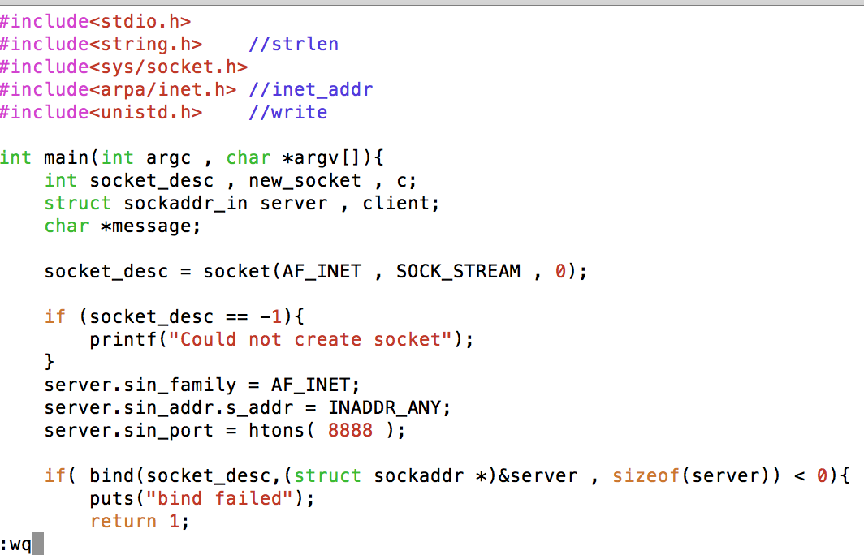

3. create a new shell scripts in client VM, to make a loop to connect with server again and again (use server ‘s IP and receive port).

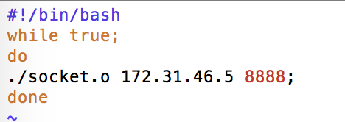

4. let server begin to waiting for connections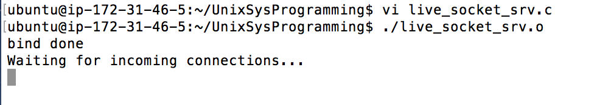

5. use command ps aux | grep live_socket_srv.o to find out PID. 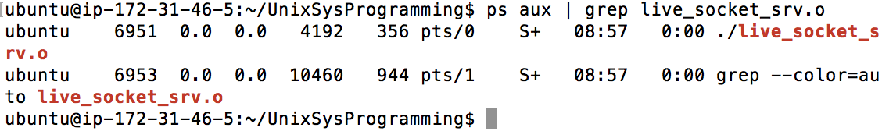

6. create a shell script named counter.sh, write a loop for counting.

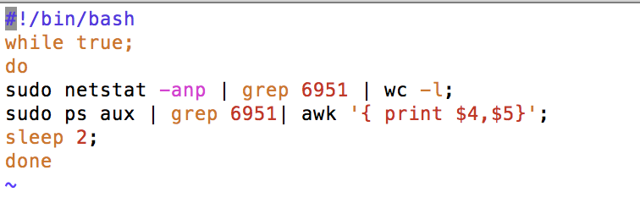

7. run countor.sh in server.

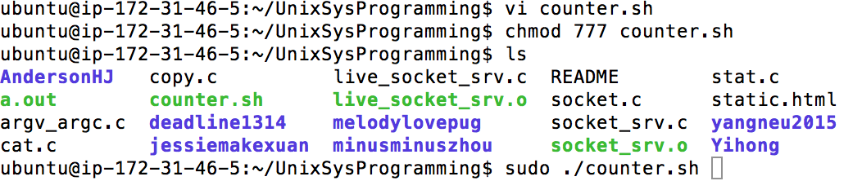

8. run connector.sh in client.

9. final result, the max server capacity is 1021

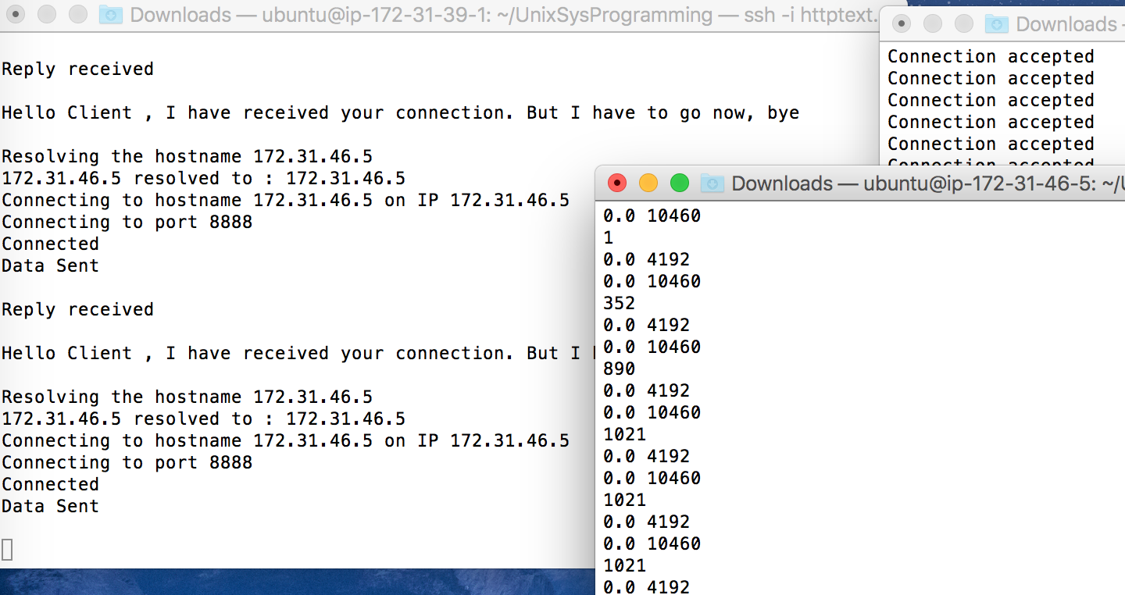

* **Launch a new VM and install tomcat HINT - Slide13**

